Create a new React Application with the name “myfirstreact”, Run the application to print “welcome to the first session of React” as heading of that page.

1. To create a React Application with the name of “myfirstreact”.
2. Once the App is created, navigate into the folder of myfirstreact .
3. App.js

import React from 'react';

function App(){

  return(

    <h1>Welcome the first session of react</h1>

  );

}

export default App;

1. Run the following command to execute the React application:

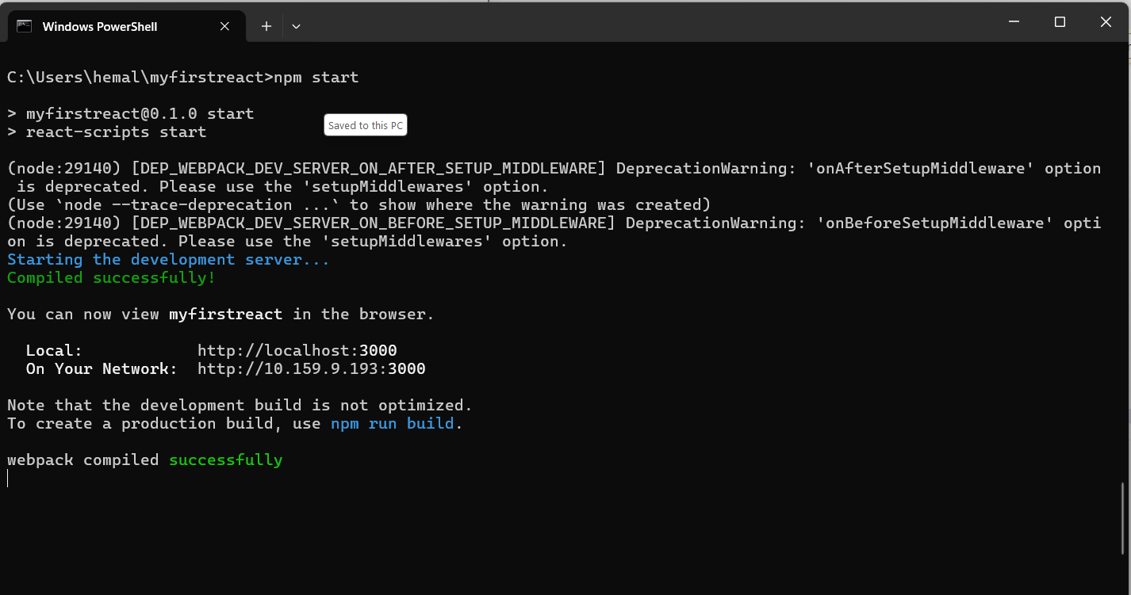

1. Open a new browser window and type “localhost:3000” in the address bar

